CAUTION RADIATION

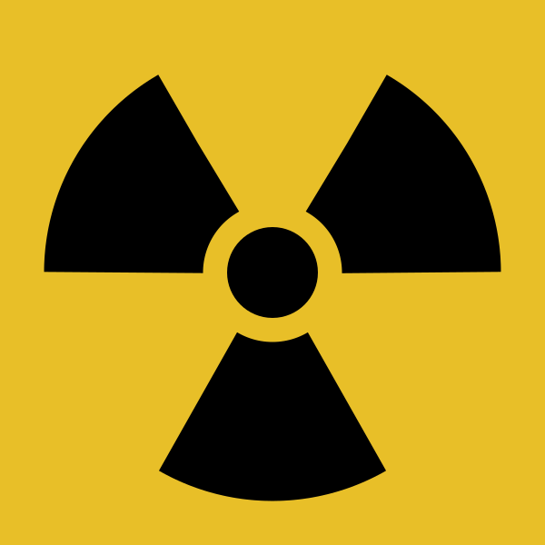

Unauthorised use is prohibited.
Hazardous radiation is emitted when the radioactive material is exposed from its shield.

Do not enter room without the correct protective equipment.

PLEASE TELL US IF YOU SUSPECT YOU MIGHT BE PREGNANT


RADIATION AREA

Facility name: | [Facility]
Location: | [Building/Room]
Classification:  (as per the Radiation Control Regulation) | [‘Irradiating apparatus’ or for radioactive substances, refer to Schedule 2 of the Radiation Control Regulation 2013]
Occupier: | [School/Department]
Radiation Management Licence holder & number: | Charles Sturt University  5061200

In an emergency, contact:
Security: | 1800 931 633
Facility manager: | [Name], [Phone]
Alternate contact person: | [Name], [Phone]

Personal Protective Equipment (PPE)
Required:    Enclosed Shoes  Personal Monitoring Device (PMD) | Upon instruction:    Eye Protection (Safety Glasses)  Protective Clothing Lab Coat  Gloves

NO EATING, DRINKING OR COSMETIC APPLICATION
AUTHORISED ENTRY ONLY

