The newly refreshed Web Kiosk
CSU has renewed the Web kiosk to reflect the CSU branding and reveal a cleaner approach.

What is Web Kiosk?
The Web Kiosk is a feature to the CSU HR information system. It enables staff members to access information online regarding:
- payslips
- leave balances
- personal details
- bank details
- emergency contacts

The new Web Kiosk Dashboard
The refreshed Web Kiosk will make it easier to find information you need instantly and assess to search functions.
This new system and layout will be available from 21 Sept 2020.

New terminology?
Tiles – the boxes which are presented on the Dashboard.
The new tile concept provides a cleaner approach to presenting your items.
Dashboard – is the first screen presented, laid out with 3 different areas. The “to do list”, favourites, and recently visited pages.

After following the Steps in the document “How to enter the Web Kiosk with new security measures”
You will be greeted with the new version of Web Kiosk (see next page)

Navigating within Web Kiosk - Home Page
See below for a quick overview.
Search feature, can go directly to them
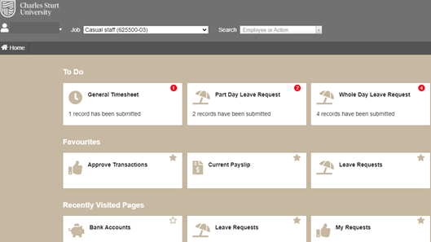
Your present Job title
Your name
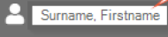

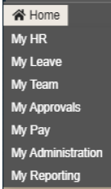

To Do List – for example approvals been submitted but not approved

Click on the Tile to go directly to that program
Used to find areas My Pay, My leave (similar to Old web kiosk)
Your Favourites, you can change your favourites at any time. (via. the star)

Recently visited pages on display. (this will show automatically)

To Do Lists
Displays actions items based which are waiting for action to be made.
The RED number indicates the number of items needing to be fixed. (eg. 4 records)
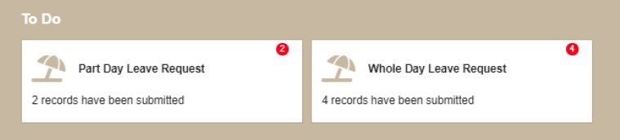

Click on the tile to open the page and then action the items.

My Favourites
These are listed in alphabetical order, there is no limit on the number of items that can be added to Favourites.
Click on the tile to open the program directly.
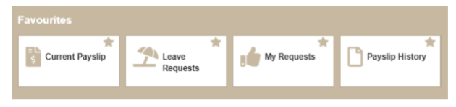

Click on the star to add/ remove items from favourites. A solid blue star means the item is added.
The outlined star means that the item is not added to favourites.

Recently Visited Pages
As you access programmes within the Web Kiosk you recently visited pages list will be updated with the last 5 (five) programs you have visited.
The most recently visited page appears first on the list.
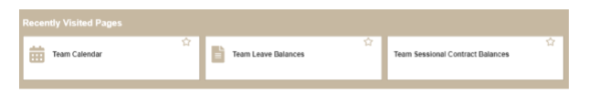

The 3 areas for the General user
Under the Home area (top right corner), you will find the three (3) basic areas. My HR, My Leave and My Pay.

My HR
In this area is where you can change your personal details (contacts), view and/or change your Emergency contacts, view EEO information, Employment Attributes as well as an Employee Calendar.

Press on each “Tile” to enter into each area.

To return out of the screen and back to the My HR area , press the RED Back button.

There is a button for PRINT and fit to screen as well in the area. You will find these buttons on each area to go back and the print material.

My Pay
This area is where all information relating to Pay is located. Your current payslips, your historical pays from past years etc.
It will have the following tile areas. Current payslip, Payslip history, Bank account, Payment Summaries and Payment
History.

As before, click on the tile you wish to enter.

How to Find my Current Payslip
Go to Home (located top left hand corner), then go down to My Pay and press on the tile Current Payslip. You will greeted with your current payslip.

As before press the RED Back button or the RED Print button. (if required)

How to Find my Bank Account Details
Go to HOME (top left hand corner), then down to My Pay. Under the Payroll details screen, Press on the Back Account tile.

You will be greeted with the Bank Accounts area.

You can change your current Bank account details by editing . You can also add a new record by pressing the RED sections.

You will be greeted by another screen. Enter the details.

Once completed press the INSERT button to finish.
**** REMEMBER –If you are changing any details, like your address, banking details. It is also essential to notify CSCS of these changes. You will need to fill in the Employee Change of Details Form.
Once filled out hand over to your supervisor for processing.

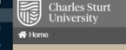
How to get to the My Leave Page
From the Home page, top left hand corner find the Home icon.

Scroll down to find My Leave.

You will be greeted with the My Leave area.
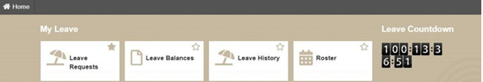

This page will show all the items, such as Leave Balances, leave history, leave requests and a countdown clock to show exactly how long before your next leave.

As before, you can use the star to Add/ remove from the Home page. (for example, Leave request tile can be placed on the Home page as a Favourite is desired)

How to get back to the Home page
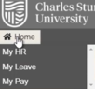
Clicking on the Home link, located on the top left corner to return to the Home Page.

Leave Booking Requests
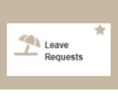
To make a leave request. Select My HR, then leave, then Leave requests.
If it is a Favourite on your Home Page, press on the Leave request tile.

A solid STAR indicates it is a Favourite

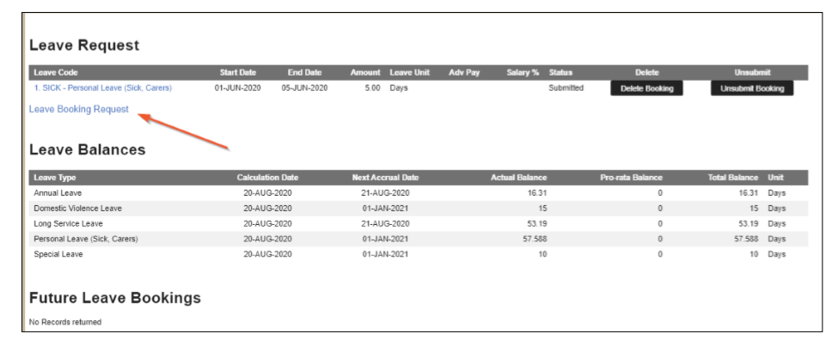
You will be shown a different screen. To enter a leave booking select the blue Booking Request area.

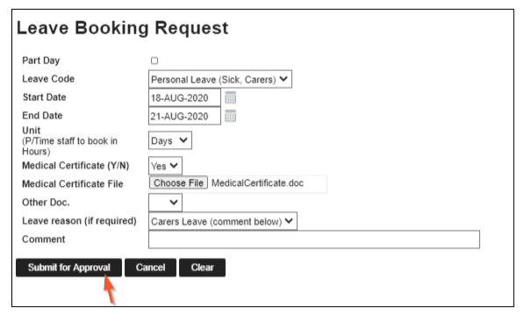
Enter the appropriate information into the boxes. (see next page for leave wording definitions)

Part Day – Pick this checkbox if the leave request is for part day. (Please note this must be done prior to selecting a leave code to trigger the correct fields for booking type and units for part day leave)
Leave code – Pull down the drop down list and select the appropriate code by clicking on it.
Start date – Enter the date the leave is to commence.
End date – Enter the date that the leave is to finish (this field will not display if the Part Day checkbox is ticked)
Unit – Enter the date for the leave booking eg. D for Days, H for Hour (this field will not display if the Part Day checkbox is ticked)
Hours – Enter the number of hours required for a part day booking. This field will only display if the Part Day checkbox is ticked.
Medical Certificate – Enter Y if you have a medical certificate for sick leave or N if you do not. This is a mandatory field for Sick Leave bookings in excess of 3 working days. * Click on the browse button and navigate to add and attach the document.
Reason – Choose a reason for the leave from the drop down list.
Comment – Enter any additional information in here as comments.
---------------------------------------------------------------------------------------------------------------------------------------------------------------

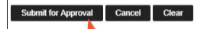
Actions to complete the leave request are a follows.
Press the Submit for Approval button.

Can press the “Clear” to reset the screen (and display a new Leave booking request screen)
Can also press “Cancel” to return back to main Leave request screen.
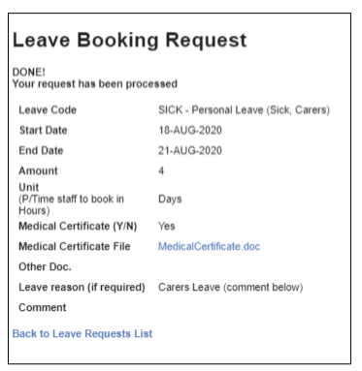
NOTE : When the booking is submitted, it is not automatically approved. There is a system in place to check your available balance for this type of leave. Talk to your supervisor about your leave entitlements.

Your Request list will display all current and future leave bookings that have been submitted for approval, or have already been approved by your Supervisor.

Change Jobs within CSCS

If you change jobs across your working life at CSCS, you will need to change your view in Web Kiosk to a specific job when needing to book leave or look at the history at that appointment.

- Select the relevant job from the list in the top menu. The context of pages will change to that of the selected job. Some pages will include more tiles, for example Timesheets.
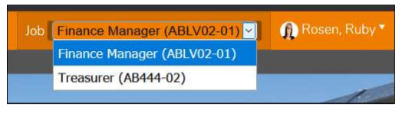

Logging Out of Web Kiosk

To exit the Web Kiosk use the Logout option. This is located at the top left hand side of the navigation screen on the menu.
Press on the name area, then scroll down to Log out.

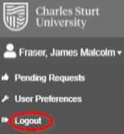

Help and Assistance
If you are experiencing difficulties with Web Kiosk and require more assistance, email the HR Service centre, hr@csu.edu.au or the IT support on 1300 653 088.

