Section Three
Agriculture, soil and changes to biomes

Learning aims:
- This section is designed to focus on how agricultural practices change biomes by changing soil.
- Students will learn about some of the causes of land degradation, and the practices that Australia farmers are using that can restore soil health

Introduction to biomes
Teacher introduces and elaborates on the concept of biomes, including natural biomes and human-induced change to biomes. What is a biome? What are the world’s major biomes? Explain and illustrate marine, freshwater and terrestrial biomes. What biomes occur in Australia? What human activities impact on biomes in Australia (e.g., urbanisation, agriculture, mining)?
It is assumed that teachers will have their own preferred resources for introducing this topic.
Soil, agriculture, and land degradation
Soils differ between biomes, but agriculture has also changed the nature of soils in the biomes in which it operates. In some areas, this has led to land degradation, or the loss of soil health and integrity through processes such as erosion, salinity, acidity, compaction, and loss of fertility. In this section, we will look at some of these changes, and the practices that farmers are using to restore their soils.

CLASS DISCUSSION: WHAT IS ARABLE LAND?
Teacher works with class as a group to define arable land.
In addition to the following content, you may wish to introduce this discussion by showing the class the video of Matt Evans using an apple to demonstrate the amount of arable land across the globe. (see link in slide 2 of the PowerPoint, the relevant content starts at 6 minutes).
The following map shows different land uses across Australia. Using your definition, which areas are ‘arable’?
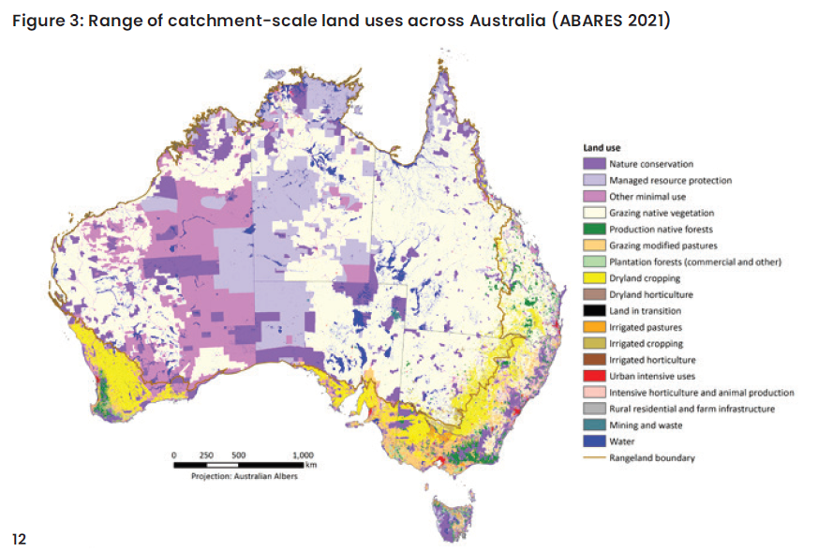
Source: National Soil Strategy DAWE 2021, National Soil Strategy, Department of Agriculture, Water and the Environment, Canberra, April. CC BY 4.0. ISBN 978-1-76003-395-8.
Note: Land degradation or quality differs not only across regions, but also within them, and even within one farm.

CLASS DISCUSSION: INTENSIVE AGRICULTURE AND LAND DEGRADATION IN AUSTRALIA
Show the students the ‘Assessment Soil Health’ content on the State of Environment website then ask the class to identify the assessment of soil health in different land use zones. Which areas have the worst soil health? (Note: use the link in the PowerPoint presentation (slide 6) to navigate to the “Assessment soil health’ section).
Processes that degrade soils
Soil scientists distinguish between different types of soil degradation
  - Physical: Erosion, compaction
  - Chemical: Salinity, acidity, loss of nutrients
  - Biological: Loss of soil microbes, organic matter depletion
Soil degradation is caused by a range of factors including drought, and climate change. In Australia, the introduction of rabbits was a significant cause of erosion.
According to the Australian government’s State of the Environment Report (2021), Agricultural land use is an important cause of soil degradation, including:
- changes to native vegetation caused by fire, clearing, grazing, and cultivation, leading to salination and erosion
- intensive use of inputs such as fertiliser, herbicides and pesticides
- intensive use of practices such as irrigation, tillage, heavy machinery – these can degrade soil through acidification, topsoil loss (erosion), nutrient imbalance, compaction, reduced biological activity and organic carbon loss
In vulnerable dryland regions, human-induced soil degradation is an important contributing factor in desertification, defined as a persistent or irreversible reduction in the capacity of ecosystems to supply ecosystem services for decades (Becerril-Piña & Mastachi-Loza 2019).
(Source: https://soe.dcceew.gov.au/land/environment/soil#vegetation-cover-as-a-national-indicator-of-soil-health-and-erosion-risk)
One example of soil degradation in Australia is sub-soil compaction in the Western Australian wheatbelt region. Some soil types are more prone to compaction but agricultural practices such as the use of heavy machinery increases the compaction. Compacted soils lead to problems with plant growth, as roots cannot penetrate the soil and gain access to moisture and nutrients stored in the soil. In WA, this has led to crop failure.
Land clearing is an important cause of soil degradation, both in Australia and internationally. Land clearing makes soil erosion more likely and contributes to pollution of rivers and systems such as the Great Barrier Reef. Land clearing is a cause of climate change and may also impact habitats for local wildlife. In Australia, much of the land clearing occurred last century, and land clearing is now regulated. However, land clearing for agriculture in Australia is still occurring. You may like to delve deeper into this issue through the following resources.
Recent data on land clearing in QLD | (https://wwf.org.au/news/2022/queensland-remains-the-land-clearing-capital-of-australia/).
Craig Reucassel discusses ongoing land clearing in QLD. | https://www.abc.net.au/education/fight-for-planet-a-ch-8-the-problem-with-land-clearing/13500110
Recent data on land clearing in New South Wales | (https://www.environment.nsw.gov.au/news/nsw-land-clearing-data-released;

The early history of land management and land degradation in the Central West Region of New South Wales
In Australia, many of these causes of land degradation are historical, and have been the result of lack of understanding of the nature of the Australian environment and soil by early European settlers. For example, the ecologist David Goldney has examined how early European settlers in the Central West region of New South Wales adopted farming practices that led to significant changes to the landscape and soil (https://www.youtube.com/watch?v=kPLmvpgezQk).
The Central West was opened up to European settlement in the early 1800s, and was the first inland area that was used extensively for agriculture by European settlers. The area had fragile and shallow soil but to the early settlers it appeared “deceptively fertile”, with lush green grass and many marshes and swampy meadows that helped retain moisture. For the early settlers, “ignorance was bliss”, and Goldney describes how they changed and “dried out” this landscape within the course of a few decades through intensive grazing, ploughing (tillage), and other agricultural practices. Goldney quotes from an early account of the area by JD Lang, who described the “natural state” of the area encountered by early explorers.
The country in its natural state, before it was covered with the flocks and herds of the colonialists, was enveloped…in a mantle of indigenous grass which…was generally tall enough to reach to the saddle girths of the early explorers, and waved luxuriantly as far as the eye could reach.
Lang goes on the describe the impact of introducing cattle and sheep into this environment, which led to drying out, and compaction.
The “natural state” described by Lang was the result of careful management by First Nations (Wiradjuri) people using firestick burning, a practice that had been used by indigenous Australian for centuries. In the Central West of New South Wales, firestick burning helped build soil carbon and maintain soil moisture, and created the park-like appearance of the plains observed by early explorers.
Note: You may wish to discuss in more detail the practices used by First Nations people prior to European settlement (including fire stick burning), and the impact of European settlement on people and landscapes. Some useful resources include Bruce Pascoe’s Dark Emu, and the following SBS article (https://www.sbs.com.au/voices/article/firestick-farming-how-traditional-indigenous-burning-protected-the-bush/xc9ovv8l7).

How are Australian farmers responding to the problem of soil degradation?
Many Australian farmers have moved away from practices that have caused soil degradation, and adopted sustainable land management approaches which help rebuild soil health. For example, Australia is a world leader in no-till and minimal till agriculture. You can read more about the history of minimal and no tillage in the following source (https://grdc.com.au/news-and-media/audio/podcast/tillage-systems-over-the-last-50-years).

The Department of Agriculture, Fisheries and Forestry regularly conducts research on the practices being used by Australian farmers.
Agriculture accounts for over half of Australia’s land use so the sustainable management of this land is an important issue for both farm businesses and the general public. There are many sustainable land practices that have become standard for Australian farmers (Coelli 2021). For example:
- many broadacre cropping farms retain stubble (85% of farms), minimise tillage (68% of farms) and optimise the use of (and reduce reliance on) pesticides or fertiliser (65% of farms)
- many livestock farms are using a variety of grazing management systems such as cell, trip or rotational grazing (61% of farms) and setting a long-term groundcover requirement (61% of farms).
(Source https://www.agriculture.gov.au/abares/products/insights/snapshot-of-australian-agriculture)
These practices can help to make soils more fertile, and more resilient from threats such as dust storms, and drought.
The following two infographics can be used to discuss (i) the practices farmers are using to do this and (ii) the benefits of doing so. These include, but are not limited to, climate change mitigation and food security.
Note that not all of these practices are applicable in all contexts, and what is good soil stewardship can even differ from season to season.

KEY TAKEAWAY: Not all soil degradation is permanent. Farmers can use soil management strategies that can restore soil health over time.
CLASS ACTIVITIES
Class discussion: case study analysis
Show students this case study about a sugarcane farmer in Far Northern Queensland
- What are the soil stewardship practices mentioned in the article?
[crop rotation; controlled traffic]
- What are the benefits to the farmer of using these practices?
[save money on inputs but maintained yield]
- What are the benefits to the soil mentioned in the article?
[increased soil fertility; better water holding capacity]
- What are the benefits to the wider community/environment mentioned in the article?
[reduced run-off into the Great Barrier Reef]
- Can you think of any other benefits not mentioned in the article?
[nitrogen fertiliser contributes to climate change – reducing its use is good for the climate]
- What additional costs might farmers face from using these practices?

Individual or groupwork: Case study analysis
Provide students with the case study about a farming family who attempt to restore the health of the soil in their farm. Students work individually or in groups to answer questions about this case study.

Wind erosion and dust storms in New South Wales
Wind erosion is defined as follows:
Wind erosion is a natural process that moves soil from one location to another by wind power. It can cause significant economic and environmental damage.
Wind erosion can be caused by a light wind that rolls soil particles along the surface through to a strong wind that lifts a large volume of soil particles into the air to create dust storms.
While wind erosion is most common in deserts and coastal sand dunes and beaches, certain land conditions will cause wind erosion in agricultural areas.
So, it is wind that drives the erosion, but it’s mainly the landscape and condition of the land which leads to the most damaging wind erosion
(Source: https://www.environment.nsw.gov.au/topics/land-and-soil/soil-degradation/wind-erosion)
Dust storms lead to loss of fertile topsoil, and are an important contributor to land degradation. They also create economic and health problems for people in cities and towns. The immediate causes of dust storms are climate-related – dust storms occur when there is dry weather or drought combined with wind. Dust storms are more likely to occur in grasslands or shrublands. These biomes are typically flat, meaning that the wind is not naturally slowed down. These biomes have natural protection against wind erosion because native vegetation (including deep-rooting grasses and native shrubs) helps hold the fragile topsoil together and creates wind breaks. However, in times of drought, ground cover may reduce, making land more vulnerable to wind erosion.
Agricultural practices that change native vegetation can make these biomes more vulnerable. Clearing native vegetation (shrubs and small trees); overstocking; regular ploughing; and leaving ground bare between crops all make wind erosion more likely. In Australia, farmers are also adopting practices to minimise the risk of dust storms and keep their valuable topsoil on their farms.
Read this New South Wales government article about how farmers can prepare before a forecast dry period to reduce the risk of dust storms.
Engage the class in a discussion using the following questions:
- What biomes are most vulnerable to damaging wind erosion (dust storms)?
- What are the primary natural causes of wind erosion?
- What agricultural practices make wind erosion and dust storms more likely?
- What practices are farmers using in New South Wales to reduce the risk of dust storms?
There are many other examples of Australian farmers successfully restoring their soils through soil management practices. Some other options for case study research and discussion include:
  - Dryland salinity in Western Australia – Farmers are restoring saline soils using deep-rooted perennials and saltbush.
  - Compaction and erosion in Queensland – Farmers are reducing compaction and erosion through rotational grazing.

