Technical Troubleshooting Guide for Supervised Assessments (Teams)

For Markers & Academics Facilitating Supervised Assessments
This guide supports consistent, defensible practice when conducting supervised assessments via Microsoft Teams.
Self-Check Before Every Session (Marker Responsibility)
Markers are responsible for confirming their own technical readiness prior to commencing the assessment.
10 Minute Pre-Session Technical Check
Environment
✔ Quiet, private room
✔ Neutral background (no distractions)
✔ Good front lighting (avoid backlighting)
Hardware
✔ Laptop/desktop (preferred over tablet/mobile)
✔ Headset plugged in (recommended)
✔ Laptop plugged into power
✔ External mouse connected (if needed)
Connectivity
✔ Stable Wi-Fi (ethernet preferred if available)
✔ Close high-bandwidth applications (e.g., streaming, large downloads)
Teams Device Check
- Open Teams.
- Go to Settings → Devices.
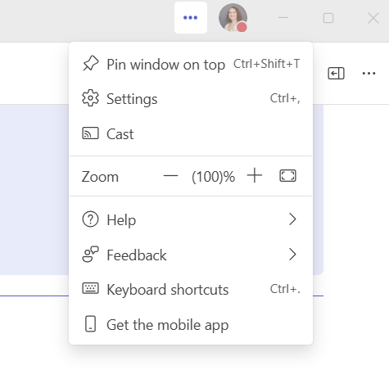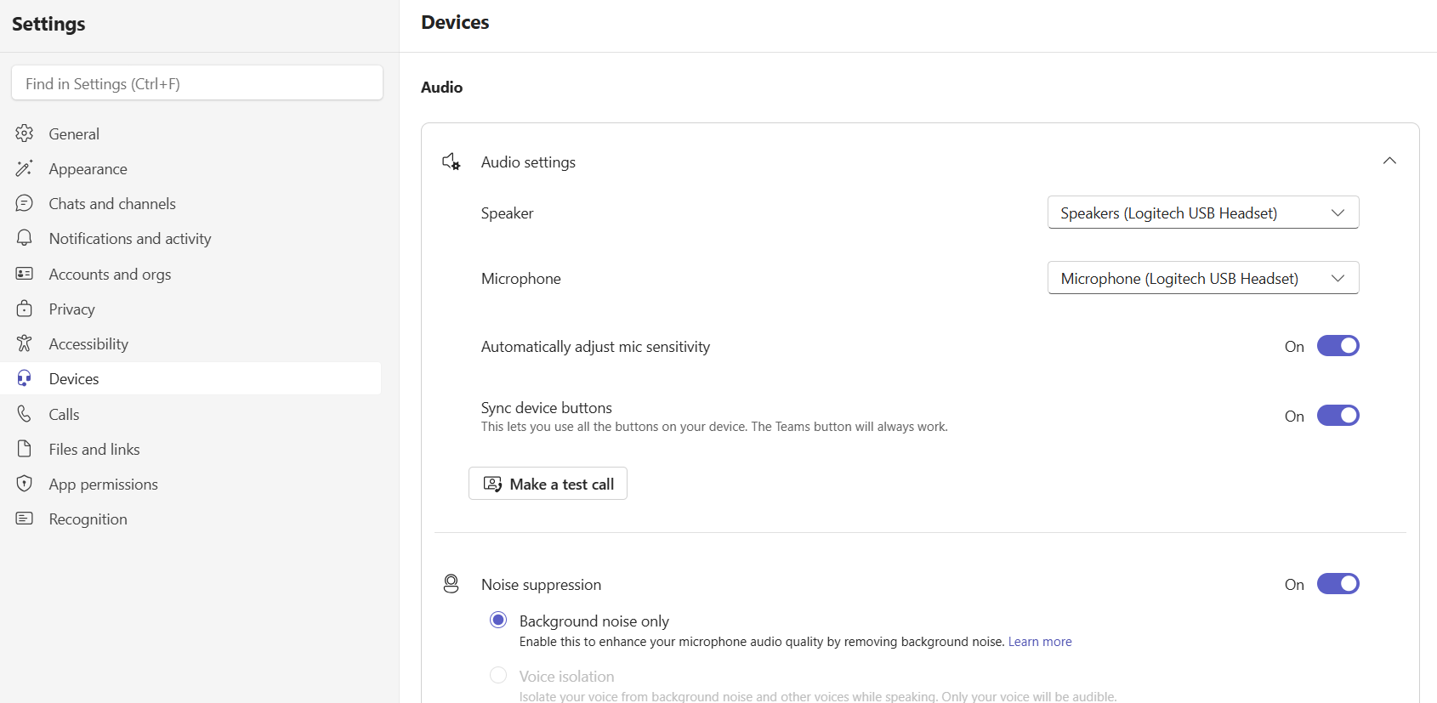
- Confirm:
  - Correct microphone selected
  - Correct speaker/headset selected
  - Correct camera selected
- Make a test call.
Bookings & Access
✔ Confirm you have the correct meeting link via your CSU Outlook calendar.
✔ Confirm student name and scheduled time.
✔ Have student email accessible in case of disconnection.

Common Student and Marker Technical Issues
Student Cannot Join the Meeting
Possible Causes
- Incorrect link
- Wrong account
- Browser incompatibility
- Outdated Teams app
Resolution Steps
- Confirm correct link. If not, provide the link from the calendar invitation.
- Ask student to:
  - Use Chrome or Edge.
  - Allow camera/mic permissions.
- Suggest opening via Teams desktop app.
- Re-send link if needed.
If unresolved:
- Pause and reschedule.
- Document the issue.

No Audio (You Cannot Hear the Student)
Rapid Diagnostic Questions
- “Are you muted?”
- “Can you check your microphone by using the drop-down arrow next to the microphone icon?”
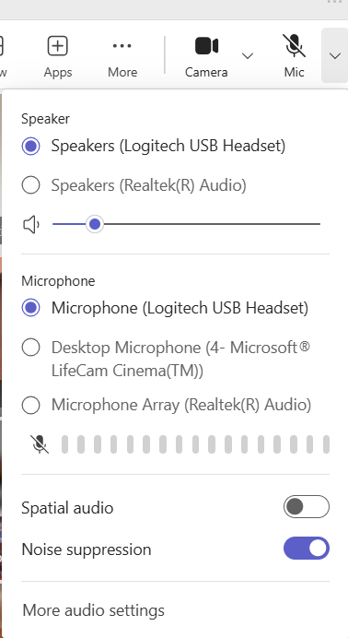
Resolution Steps
Student:
- Unmute.
- Select correct microphone in Teams settings.
- Leave and rejoin.
- Restart Teams.
Marker:
- Confirm your own device settings.
- Ensure system volume is not muted.
- Check headset connection.
If unresolved:
- Dial-in option (if enabled).
- Note incident and reschedule.

No Video / Camera Not Working
Student:
- Confirm camera icon is enabled.
- Check Settings → Drop-down arrow.
- Close other apps using camera.
- Restart Teams.
- Restart device if time permits.
If the video issue cannot be resolved:
- Note incident and proceed.

Poor Internet / Lag / Freezing
Immediate Actions
Ask student to:
- Move closer to router.
- Turn off other devices using Wi-Fi.
- Close background apps.
- Remove virtual background.
Marker should also:
- Confirm no large downloads are running.
- Close unnecessary browser tabs.
- Turn off background effects.
- Turn off camera.
If connection drops:
- Wait 2–3 minutes.
- Student rejoins using same link.
- Note interruption duration.
Repeated instability:
- Pause session or reschedule.

Echo or Feedback
Causes
- No headset
- Two devices in same room
Fix
- Require headset.
- Remove secondary device.
- Mute duplicate connection.
If the issue cannot be resolved:
- Note incident and proceed.

Screen Sharing Issues (If Required)
If sharing:
- Confirm correct screen selected.
- Stop and restart sharing.
- Check dual monitor selection.
If student required to share:
- Confirm entire screen visible.
- Ensure clarity of display.
Marker should also:
- Ensure sharing rights are enabled for guests.

Teams Crashes
- Close Teams fully.
- Reopen and rejoin.
- Restart device if persistent.
- Join via browser as interim solution.
Have student remain in meeting while reconnecting.

Identity Verification – Visibility Issues
If ID unclear:
- Ask student to:
  - Move closer.
  - Adjust lighting.
  - Hold ID steady.
  - Reduce glare.
If still not verifiable:
- Note issue and proceed with the assessment.

Escalation & Documentation
If a technical issue impacts assessment integrity:
Document:
- Time of incident
- Nature of issue
- Duration
- Actions taken
- Whether session continued or was paused
Notify Subject Coordinator where required.

