  - Manager Toolkit – Employee Development and Review Scheme

Professional/General and Academic Managers

People and Culture

Contents
Introduction 3
Manager Responsibilities 3
Support Available 3
General Principles of EDRS 3
EDRS Planning Guide 3
EDRS Timeframes 4
EDRS Cycle 4
People Management at Charles Sturt University 5
Preparing for the EDRS meeting 5
During the EDRS meeting 6
After the EDRS meeting 7
EDRS Manager 7
EDRS Conversation: Activities to support Managers 9
Skill/Will Matrix 9
Empower 10
Guide 10
Motivate 11
Direct 11
GROW Coaching Model 12
Effective Questioning 12
Active Listening 13
Feedback Tips 13
EDRS Conversation: Career Planning Questionnaire 14
EDRS Conversation: Focus on Future Performance 15
Capabilities 15
Career Interests 15
Network 15
EDRS Conversation: Guide to Delivering Performance Reviews 16
Checklist for an Effective Review Discussion 16
EDRS Conversation: Email template for Managers 17
EDRS Conversation: Additional Resources for Managers 18
Glossary 20

Introduction
In this toolkit, you will find guidance, activity sheets, resource links and templates relevant to the Employee Development and Review Scheme (EDRS) at Charles Sturt University.

Manager Responsibilities
The best place to start is to get familiar with this toolkit. The Table of Contents provides an overview of what will be covered. Use the glossary in this guide, and/or talk to your manager to clarify and understand the EDRS process. Your role as manager is to give feedback and advice. Provide information to your employees about workplace policies and procedures in relation to the EDRS process. Make sure you ask questions, understand the answers, and seek feedback and clarification where required.

When reviewing this toolkit, you should:

- Review the learning materials and consider how to apply them to your conversations
- Seek out people and information that can increase your knowledge of the EDRS process
- Share information, knowledge and resources available to your team/s

Support Available
The People and Culture Business Partner Team provide support for managers to prepare for and undertake the EDRS process. This can be general advice about the process through to coaching sessions, providing tools and reports to ensure you as a manager are confident and feel supported throughout the process. You can contact your relevant People and Culture Business Partner to discuss your needs prior to undertaking the process so appropriate support can be tailored as required.

General Principles of EDRS
The following principles apply to EDRS:

- Aligned to Charles Sturt organisational strategic objectives and priorities
- Encourage a culture of high performance to support individual and organisational development
- A fair and equitable process, and incorporates the principle of natural justice
- Clearly articulates development expectations
- Provides ongoing feedback and support
- Is a shared responsibility
- Employees take an active role in their own ongoing professional learning and development
- Is undertaken in a professional manner and aligns with the Charles Sturt values and behaviours

EDRS Planning Guide
The Employee Development and Review Scheme is the formal review process at Charles Sturt. The EDRS process allows employees and managers the opportunity to review the previous year’s work and set work and development objectives for the coming year.

The intent of EDRS is to encourage meaningful conversation between the employee and the manager. The conversations need to be balanced, open and honest and to ensure the employee is equipped to perform their role effectively.

EDRS serves the following purpose:

- Setting and reviewing work objectives
- Professional development – Identifying the appropriate level of support and development to achieve the employee’s objectives
- Support from Charles Sturt to achieve work and professional development

EDRS Timeframes
EDRS meetings for professional/general employees are formally held from January – March and then informally every three months throughout the year. For academic employees this is from October to December and then informally every three months throughout the year. The goal is for the employee and the manager to have a common understanding of the work undertaken by the employee; that the work is focused, with clear expectations around performance and behaviours; and that the employee’s development is designed to meet current and future professional needs.

EDRS Cycle
EDRS is part of Charles Sturt’s planning and review cycle. It starts with Charles Sturt’s strategic objectives and priorities and the review of Faculty/School/Division/Centre Plans. These plans provide the basis for performance planning. They establish a regular periodical review in which each employee works with their manager to monitor progress and achievement of the approved objectives and standards.
Ongoing coaching, feedback & development

People Management at Charles Sturt University
EDRS is integral to the success of people management at Charles Sturt University and is an ongoing process that allows us to:

- Align everyone’s work with Charles Sturt objectives and priorities
- Fully develop people into their positions
- Encourage individual planning of professional learning and development

Preparing for the EDRS meeting
To get the best out of an EDRS meeting, it is important you adequately prepare yourself and your team. Take some time to consider your team, ensuring you refresh your understanding of your employees, for example, the various levels of appointment, employees on a fixed term contract or an employee who is on probation and needs to link probation goals with their new EDRS plan.

Prepare for the Conversation
To ensure you have a meaningful conversation with your employees it is recommended that you prepare and utilise practices and resources available to support the conversation. This may include:
- Knowing your content which is gathering evidence, for example:
  - Reviewing the relevant EDRS resources and guides
  - Understanding Charles Sturt Strategy, Ethos and Values
  - Consider Faculty/School/Division/Centre plans
  - Awareness of policies including Code of Conduct and Employee Generic Responsibilities
- Seeking support – consider any pre meetings which may be helpful including your manager or People and Culture Business Partner, who can support you in this process. This can include working with People and Culture to generate relevant reports such as leave reports for example or conducting a talent review exercise.
- Clarifying expectations – if relevant, hold a team meeting to explain the process and engage with your employees. Preparing an email to employees with information on preparation, meeting details and the ‘what’ and the ‘how’ when preparing for the conversation is beneficial.
- Knowing your employee and planning the conversation by:
- Understanding your employee and their contribution to team objectives
  - Ask your employee to review their position description to ensure it reflects the requirements of the role
  - Reflect on the work progress to date against the employee’s plan: what went well, what could be improved and how these improvements can be implemented and contribution to the Faculty/School/Division/Centre plans
  - Think about your employees’ achievements and challenges over the past year and what you would like to plan for the coming year
  - Seek appropriate feedback from stakeholders throughout the year, where appropriate or ask your employee to gather feedback
  - Ask the employee about their career aspirations

- Knowing yourself – what conditions do you need for a constructive conversation and prepare for the meeting, thinking about your mindset and demeanour. Consider setting aside at least one to one and a half hours for your meetings with each employee to engage and fully explore the EDRS conversation with the individual.

Prior to your EDRS Meeting with your employee, you will need to review the previous plan, and be prepared to discuss the draft plan for the coming year.

Review last year’s plan | Draft this year’s plan
- What the employee achieved and how they achieved it;  - If objectives were not met, why not?;  - The timeframes in which objectives were achieved;  - The evidence available to demonstrate achievements against identified measures;  - Contribution to the performance of the Faculty/School/Division/Centre and Charles Sturt. | - What you would like the employee to achieve for the plan period;  - Discuss and refine work objectives;  - Discuss and refine development objectives, based on the Charles Sturt capability framework;  - Contribution to the performance of the Faculty/School/Division/Centre and Charles Sturt.

During the EDRS meeting
During the EDRS meeting you and the employee will review the previous year’s plan and discuss the draft plan for the coming year, you may also discuss:

- What went well in the previous 12 months, recognising efforts and successful outcomes;
- What could be improved and how these improvements can be implemented;
- How the employee’s performance is contributing to the performance of the team and your Faculty/School/Division/Centre and Charles Sturt;
- How the employee is progressing on their career path;
- Request to participate in follow up meetings, as appropriate;
- How the employee has lived the values and examples of behaviours that the employee has displayed. Take the time to recognise those employees who are living the values. Address any behaviours that do not align with the values.

Other considerations may include:

- Position Description: work with your employee to review their position description and update it to ensure it reflects the work they are required to perform.
- Capability: Reflecting on the Charles Sturt Capability framework, encourage the employee to think about participating in key activities across the university or collaboration across teams and the Faculty/School/Division/Centre
- Work Agreements: discuss with your employee arrangements for working remotely and attendance on campus
- Compliance: ensure your employee has completed the required compliance training, for example ELMO modules
- Workload allocation: Were there any changes in expectations or priorities and what is the impact of work for the employee. Were there any solutions implemented to address these changes.
- Professional Development:
  - Encouraging the employee to actively seek out professional development opportunities such as the Indigenous Cultural Competency program, role shadowing or seeking a mentor
  - Aligning professional development to the learning and development 70:20:10 framework
- Career Planning: conversations could focus on the employee’s aspirations. Seek opportunities to provide support and plan for the future, considering leadership roles, if relevant.
- Support: consider any support the employee may require.
- Leave: discuss with your employee if they are planning to book extended leave or have an excessive leave balance and encourage a healthy work life balance.

After the EDRS meeting
You and your employee are both responsible for ensuring you meet at least every three months to discuss progress against your agreed objectives. Discuss how to move forward, such as actions each will take, follow up needed and frequency of meetings.

EDRS Manager
EDRS Manager is an online performance management system that supports all employees to participate in the EDRS process. The system is easy to use and supports your employee to build comprehensive work and development goals. An example of the work objective is below:

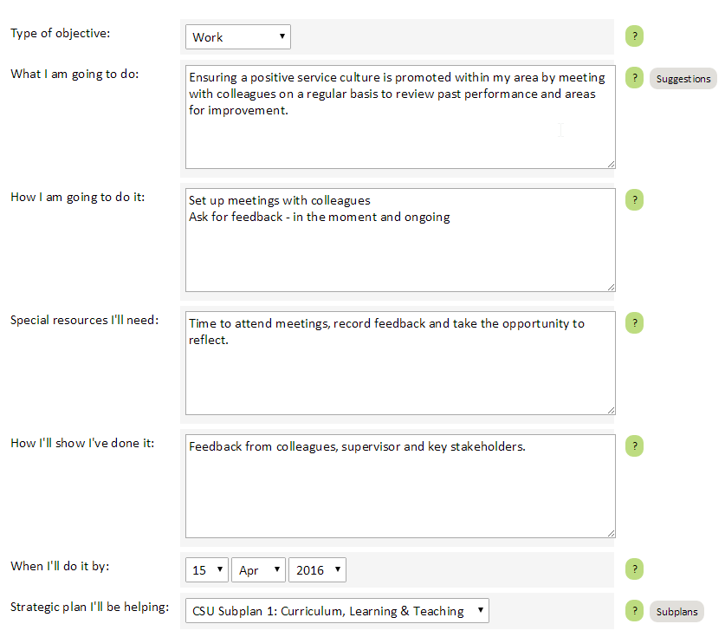
Each work and development objective is aligned to a SMART goal. SMART goals are specific, measurable, achievable, relevant and timely.

A guide for developing a SMART goal and to ensure you and your employee develop a quality plan is outlined below:

Specific  (What am I going to do?) | - What exactly needs to be accomplished?  - Who else will be involved?  - Where will this take place?  - Why needs to take place to accomplish this goal?
Measurable  (How am I going to do it?) | - How will success be measured?  - How much change needs to occur?  - How many accomplishments or actions are required?
Achievable  (Special resources I’ll need) | - Are the resources available to achieve this goal?  - Is this goal a reasonable stretch?  - Are the action likely to bring success
Relevant  (How I’ll show I’ve done it) | - Is this a worthwhile goal right now?  - Is it meaningful – or just something others think I should do?  - Would it delay or prevent me from achieving a more important goal?  - Am I willing to commit to achieving this goal?
Timely  (When I’ll do it by) | - What is the deadline for reaching the goal?  - When do I need to take action?  - What can I do today?

EDRS Conversation: Activities to support Managers

Skill/Will Matrix
The Skill Will Matrix is a simple tool that can help you identify ways to manage your employees toward success. The matrix allows you to understand different types of individuals and apply management or coaching techniques that help them to perform.

The matrix assesses two dimensions: Skill and Will.

Skill: An individual’s capabilities based on his or her experience with the role, training, knowledge, and natural ability.

Will: An individual’s desire to complete a particular role based on attitude, incentives, confidence, and personal feelings about completing the task.

4 | 1
3 | 2

Will

Skill

Quadrant 1 – a person who has both skill and will to perform their role. This is often an experienced person who is looking for more opportunities to grow and develop.

Quadrant 2 – a person who has the skill, but not the will and motivation to complete the task. This is often a skilled, experienced person who may have hit a plateau and needs a new challenge.

Quadrant 3 – a person who has neither the skill nor the will to complete the task. This is often a person who has started a new task that they did not desire. However, this may also be a beginner to a task who has low confidence and who is afraid to fail.

Quadrant 4 – a person who has the desire to complete their role but lacks the necessary skills. Typically, this is a person new to a particular task who is enthusiastic, but lacks the skills or knowledge needed.

Activity:
Think about your employees in your team/s and plot them into the matrix on the previous page, based on your assessment of their skill/will levels. Once you have plotted your team into the matrix, refer to the diagram below for the recommended management or coaching style to achieve success.

Guide | Empower
Direct | Motivate

Will

Skill

Empower
Often this is an individual who is looking for more opportunities to grow and develop. Therefore, the goal of this style is to empower and stretch employees. Suggestions for empowering:

- Provide freedom in completing tasks
- Encourage them to take responsibility
- Involve them in decision making
- Ask for his or her opinion
- Praise
- Recognise and reward success

Guide
This group is typically composed of people who are new to a particular task. They are often enthusiastic, but lack the skills or knowledge needed. Therefore, invest time early on in building the skills.

Suggestions for guiding:

- Identify and provide necessary training and tools to complete the tasks
- Set clear expectations
- Create a risk-free environment to allow for learning
- Find “teachable moments”
- Check for understanding
- Provide frequent feedback
- Praise
- Recognise and reward success

Motivate
This group is often composed of experienced people who may have hit a plateau and need a new challenge. They have the skills and ability but are not motivated. Many of those in this group have been motivated at some point, but over a period of time lost that motivation. It may be due to boredom, frustration, lack of recognition, or other reasons. Therefore, it is important to first identify the reason(s) for the low motivation.

Suggestions for motivating:

- Discuss what would motivate them
- Develop intrinsic and extrinsic motivations and incentives
- Praise
- Recognise and reward success

Direct
With this group, you have to build both will and skill. This is often a person who has started a new task that they did not desire. However, this may also be a beginner to a task who has low confidence and who is afraid to fail. Therefore, it is important to first identify the reason(s) they fall within this category.

Suggestions for directing:

- Determine the reason for low will
- Determine the reason for low skill level
- Get them motivated before building skill sets
- Discuss what would motivate them
- Develop intrinsic and extrinsic motivations and incentives
- Identify and provide necessary training and tools to complete the tasks
- Set clear expectations
- Provide frequent feedback
- Praise
- Recognise and reward success

GOAL – what do you need to achieve? | REALITY – what is happening now?
- agree/state topic  - explore meaning  - agree objective | - explore current situation  - provide feedback  - establish what is relevant
OPTIONS – what could you do? | WRAP UP - what will you do?
- invite suggestions, brainstorming  - cover a full range of options  - identify one option before moving on | - commit to action  - agree support  - make specific steps and timing

GROW Coaching Model

- used to frame conversations
- brings out the best in people
- increases level of responsibility and accountability
- maximises listening and questioning skills

Effective Questioning
- Use open questions: what, when, who, how
- Ask specific questions that need specific answers
- Keep the conversation flowing with open questions
- Why implies criticism
- Avoid leading questions or questions that invite a ‘NO’ response
- What else? – evokes more even when you think the conversation might be finished
- If you knew the answer, what would it be? – thinking outside the square

Active Listening
- Clarify - ask questions, display interest
- Restate - put the message in your own words, demonstrates you listened and understand meaning
- Reflect - mirror back image, feelings, emotions
- Encourage - ‘tell me more…’, expresses interest
- Validate - confirms it is ok to talk, ‘I appreciate your …’
- Summarise - recap the main points of the message

Feedback Tips
- Provide both positive and negative feedback
- Be honest
- Be specific
- Restrict your feedback to situations you know for certain
- Be sincere in giving positive feedback
- Focus on behaviour not personality
- Provide informal feedback regularly
- Listen
- Be timely
- Avoid being selective and influenced by judgement

EDRS Conversation: Career Planning Questionnaire
Instructions: Fill out the conversation guide using one of your direct reports as an example. In the column below, fill in how your direct report would answer each of the questions in the left column, to the best of your knowledge.

Conversation Guide
Questions | Responses
Questions About Your Current Role
- What is your favorite part of your current role?
- What would you describe as your biggest strength?
- What one skill would you like to develop to improve in your current role?
Questions About Your Future Role(s)
- Where do you see yourself in one to three years?
- Where do you see yourself in 10 years?
- If there is one task or project type, you’d like to do more frequently in your future roles, what would you select?
- If there is one task or project type you’d like to do less frequently in your future roles, what would you select?
Questions About My Role
- How can I best help you in your current role?
- How can I best help you achieve your career goals?
- Are there other individuals you would like to enlist to help you achieve your career goals (e.g. a colleague in a role you’re interested in pursuing)?

Source: CEB analysis

EDRS Conversation: Focus on Future Performance
Instructions: Use this checklist when preparing for performance review feedback. Choose which questions you want to ask your employees and have this sheet with you as you deliver performance review feedback.

Capabilities
- Ask the employee about skills he/she wants to learn in the future.
- Talk about the skills the employee must learn and the development areas the employee needs to work on in order to continue to provide value in their role.
- Discuss how the employee’s strengths can contribute to the organisation’s vision and future goals.
- Motivate the employee to change a past negative behaviour or an under-developed skill and discuss the outcomes if the employee changes his/her behaviour.

Career Interests
- Ask the employee about their future career interests and aspirations.
- Discuss whether the employee’s future career aspirations align with the organization’s vision and purpose and, if not, then how can the two align.
- Discuss the possible career paths available to the employee given the organisation’s vision and strategy for the future.
- Discuss how the career progression would look for at least two positions above the employee’s current position.

Network
- Ask the employee about the types (role-related, technology-related, process-related, etc.) of networks he/she is interested in being connected to based on his/her future career aspirations
- Discuss the types of networks the employee needs to be connected to in order to be successful in future roles and how the organization can help him/her connect to them.
- Discuss the employee’s current networks and how they can contribute to a high level of future performance.
- Discuss the peers and senior leaders who could have a positive impact on the employee’s future performance as mentors and coaches.

EDRS Conversation: Guide to Delivering Performance Reviews

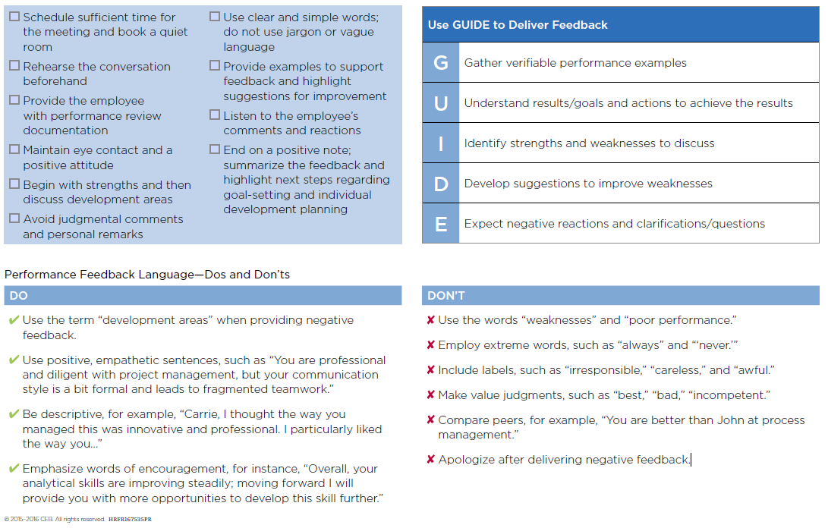
Checklist for an Effective Review Discussion

EDRS Conversation: Email template for Managers
Instructions: Use this sample email when preparing your communication to employees outlining expectations for the performance review. Please note this is a sample template and modifications required to this template are underlined below.

Dear insert name

As we approach the review cycle for the Employee Development and Review Scheme, I would like to share with you the process for completing your EDRS and the focus should be:
- Closing out the current plan period by insert specific date

Focus on: reviewing achievements, objectives not met, areas for improvement and reflection on professional development undertaken

Tool: your plan should be at Stage 3: Approved in the EDRS Manager Tool. Ae we move towards the end the plan period you will need to make comments about how the plan has gone (and attach supporting documents as required). Once you have finalised your plan, move to Stage 4: Ready to finish. This plan will be reviewed in your EDRS meeting along with the draft plan for the following period.

- Develop a draft plan for new plan period by insert specific date

Focus on: think about desired work and development objectives, and identify relevant professional development opportunities. Include at least one ‘values objective’ as a focus for the coming year.

Tool: you are required to develop a new plan for the coming plan period. Once you have finalised this draft plan, you need to move the plan to Stage 2: Ready to approve. This plan will form the basis for planning work and development objectives for the year ahead.

Recommended focus areas (dependant on the business area)

- Faculty/Division/University strategic priorities
- Team objectives
- Values Objective: focus on the values demonstrated throughout the year and link to a future values objective. All employees are expected to have one values objectives for their XXXX plan.

EDRS Meetings

Individual EDRS meetings will be scheduled from INSERT DATE HERE. As mentioned earlier the focus of the conversation will be reviewing outcomes from the current plan and finalising a new plan for the year ahead. The conversation will focus on:
- Your role, responsibilities, deliverables and projects
- Teamwork, engagement and contributions to the Faculty/Division/Charles Sturt
- Professional development
- Career planning
- Leadership (if applicable)

There are a range of tools and resources to support your conversation and this is available on the EDRS homepage INSERT LINK HERE. This includes access to the tool, a guide focusing on how to plan for your EDRS conversation and webinars on how to use the tool (creating and finalising your plan). I encourage you to make the most of the tools and resources that are available to you to plan and prepare for your EDRS conversation.

EDRS Conversation: Additional Resources for Managers
Further to the resources provided in this toolkit, some additional resources to consider include:

- Faculty Operational Plans
- Curriculum Learning and Teaching Framework and Quality Learning & Teaching Standards
- Research Narrative and the Research Professional Development Calendar
- Research Activity Data (provided to Faculties from the Research Office)
- Student Evaluation Surveys (SES)

Further areas of focus, aligned to our Charles Sturt Capability framework could include;

Collaborate with Others (Networks, Listen Closely and Influence)

- Attendance on campus – agreed variations/remote working arrangements, visibility, participation in key activities at School, Faculty, University level.
- Support for sessional employees such as on-boarding and networking opportunities.
- Actively participates in and supports School, Faculty, University events.
- Contributing to attracting students and growth of the Faculty
- Involvement in School planning activities such as accreditation
- Supporting the development of other employees e.g. research support, mentoring of junior academics

Get Results (Customer Centric, Business Savvy and Innovative)

- Deliverables from activities such as SSP, Research Fellowships, time release, RHD support
- Focusing on quality Learning and Teaching KPIs
- Demonstrates appropriate focus on student centred culture: active engagement in retention of students
- Progress of students and appropriate review and improvement of teaching
- Understanding of course performance standards
- Engaging with the relevant Divisions such as Learning and Teaching and Student Services for support, highlighting students that are at risk
- Completion of the Indigenous Cultural Competency program and Academic Integrity on-line module
- Contribution to KPIs for research and research data
- Meeting research active definition for supervision at an appropriate level, and HDR supervision responsibilities and student progress
- Scholarship of teaching opportunities are maximised
- Understanding the personal impact on the student experience and delivering on appropriate student contact plans

Take Ownership (Live our Values, Take Action and Adapt to Change)

- Engaging with key Learning and Teaching policies e.g. Assessment and Moderation, Special Consideration et al
- Ensuring Teaching Professional work function is appropriate for workload investment/return
- Contributing to the profession and creating an impact
- Alignment of research program with Charles Sturt Research Narrative, and Faculty research priorities
- Undertaking the Online Learning Model V1.0 and 2.0 (if applicable)
- Research development support plans including e.g. SSP, fellowships
- Ensuring there is feedback on progress for Research Centre membership and Research Centre Director, if appropriate

Glossary

EDRS | Employee Development and Review Scheme incorporates the process of planning, monitoring, reviewing, improving and where appropriate recognising the performance of employees.
EDRS Manager | An online performance management system to support the Employee Development and Review Scheme.
Manager | Can also be known as a supervisor, team leader or Head of School.
Plan | A plan of work and development activities that have been agreed with the manager.
Development Objectives | Development objectives set by an employee and related to professional learning and developmental activities.
Work Objectives | Work objectives that are set for an employee’s current job for the next performance period. These objectives are used to measure achievement in the Employee Development and Review meeting.
Attributes | Attributes that have been designed as essential for all employees at Charles Sturt.

