APPLICATIONS CLOSE Friday 12 November 2021
Email to pvcri@csu.edu.au

Scheme Objectives:
The objectives of the ECR Grant Scheme are to:
- Support and provide mentorship to early career researchers who demonstrate clear evidence of high research potential to progress their research careers;
- Encourage establishment of an early career researcher’s research pathway;
- Provide competitive continuation funding for high quality projects and / or pilot research projects that will lead to external grant applications;
- Provide early career researchers with experience in preparing a grant application for peer review;
- Build early career researchers’ track record in producing high quality/high impact outputs in order to enhance competitiveness in bidding for external research funds;
- Provide research funding for projects that are strategically aligned with the University’s FOR priority areas.

PLEASE CAREFULLY READ THE SCHEME GUIDELINES BEFORE
COMPLETING THIS APPLICATION FORM.

Project Title:
Abstract: 100 word project summary

- APPLICANT
First name
Last name
School
Current FTE
Email
ORCID iD*
CV | Please attach CV of no more than 5 pages

*ORCID iD (Open Researcher and Contribution ID) – ORCID is an open, non-profit, community driven effort to create and maintain a registry of unique researcher identifiers and a transparent method of linking research activities and outputs to these identifiers. All Charles Sturt University researchers are expected to have an ORCID account. Create and register your ORCID iD

Online profiles
Do you have an online profile with any of the following? If so, insert your profile link into the appropriate box.

Google Scholar
Scopus ID
Academia.com
ResearchGate

- ELIGIBILITY
Your research higher degree (where relevant)
Conferred date
Degree
Institution
Has the Division of People and Culture received a certified copy of this qualification?
Career Interruption – significant career interruptions since conferral will be considered. Please provide evidence and information on the nature of the interruption and the effect on your career, if applicable.

- MENTOR
First name
Last name
School/Centre
Email address
Justify suitability
Max 200 words
Meeting schedule agreed with mentor for discussing the project and career development

- PROJECT
Attach Project Description (maximum 1500 words) to include the following sections:
- The Quality of the Project (30%)
- Researcher Development (20%)
- External Grant Focus (20%)
- Feasibility (15%)
- Resources (15%)

In your Project Description, consideration should be given to the following aspects: project overview and background; significance and innovation; approach and methods; and engagement, impact and benefit of the project.

References are not included in the word count.

- PROJECT PLAN
Include Ethics application within the Plan where required.

Activity/Action | Timeline | Outputs and/or Outcomes

- BUDGET
The budget must provide accurate costing for all proposed activities and be expended within the 10 months. Items that are eligible to be funded include:
- Staff/research assistance
- Travel (for project related activities or dissemination with community and stakeholders only, excluding conference attendance)
- Consumables
- Minor equipment
All items must be fully and realistically costed. Please utilise the Budget Approval Form and attach it to this application. A summary is to be provided below.
Example:
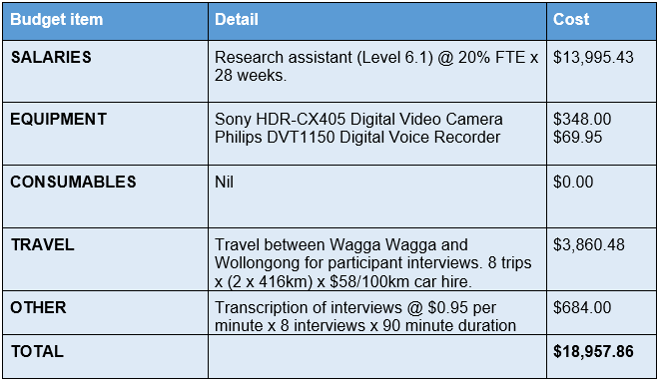
*The above example table can be deleted prior to application submission.

Budget item | Detail | Cost
SALARIES

EQUIPMENT

CONSUMABLES

TRAVEL

OTHER

TOTAL

BUDGET JUSTIFICATION – maximum 200 words
Provide justification for budget items and how they contribut to the project outcomes being achieved. Use the Budget Headings in the justification.

OTHER FUNDING
Has other funding been sought for this project YES NO
If yes, please specify:

- RESEARCH CLASSIFICATION CODES:
Indicate the relevant Field of Research (FOR) codes, and their weightings. Please ensure that the total weighting of each column adds up to 100%.
Please see full list of FOR Codes. (Please discuss priority codes with your AHOS Research or ADR if guidance is required).
FOR (4 digit code) | Weight %

- DISSEMINATION, IMPACT and OUTPUTS
Detail dissemination/impact activities
All projects must also include a dissemination/impact plan for example:
- Scholarly output;
- Conference presentation;
- Short video for use in professional learning programs.

- PROJECT ENDORSEMENT
Mentor
Name
Signature
Supervisor (HOS or AHOS Research and Graduate Studies)
Name
Signature
Applicant
Name
Signature

Attachments
Please check that you have included:
- A CV no more than 5 pages in length.
- A description of your research project no more than 1500 words.
- Budget approval form

Application documents should be collated into a single pdf file and submitted to pvcri@csu.edu.au by the closing date. Late applications will not be accepted.

Mentors should discuss the mentoring plan with the applicants prior to signing this application.

