Travel Advice for Domestic Travellers – COVID19

Please be aware of the following advice from NSW Government Health with regards to COVID-19.
Protect yourself
The best way to protect yourself from COVID-19 is the same way you would protect yourself from catching flu or other respiratory illness:
- Wash your hands for at least 20 seconds with soap and water, or use an alcohol-based sanitiser with at least 60% alcohol.
- Cover your sneeze or cough with your elbow or with a tissue.
- Avoid close contact with people who are ill.
- Avoid touching your eyes, nose and mouth.
- Stay home if you are sick.
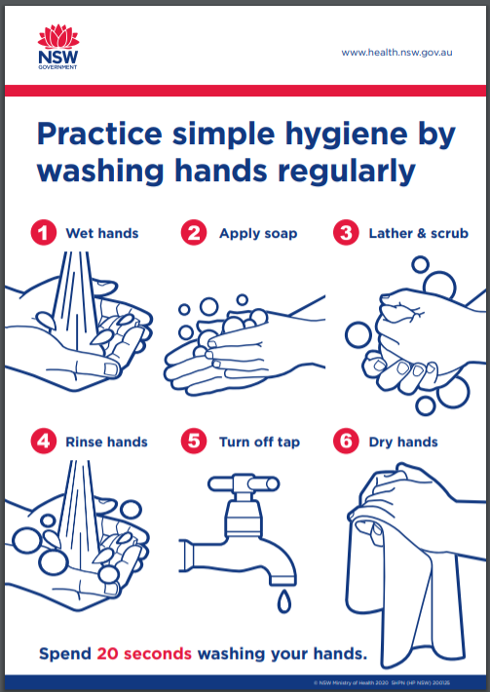
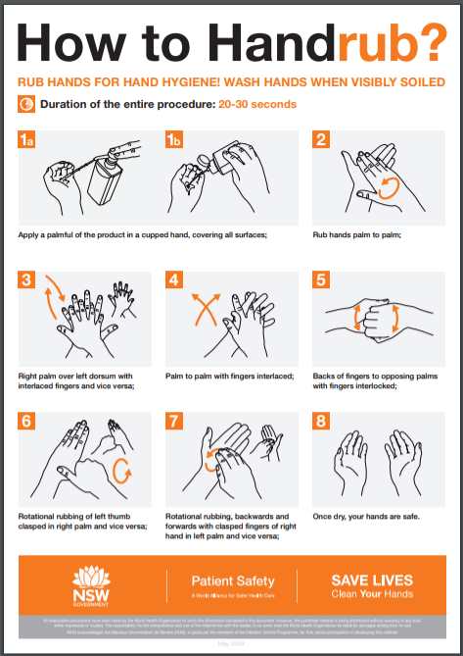
The link to the above posters and information is below:
https://www.health.nsw.gov.au/Infectious/diseases/Pages/protect-yourself.aspx
For frequently asked questions refer to:
https://www.health.nsw.gov.au/Infectious/alerts/Pages/coronavirus-faqs.aspx
Wherever possible it is recommended to practise “Social Distancing” as per the below;
Social distancing is an effective measure, but it is recognised that it cannot be practised in all situations and the aim is to generally reduce potential for transmission.
While practising social distancing, people can travel to work (including public transport). For non-essential activities outside the workplace or attendance at the university social distancing includes:
- avoiding crowds and mass gatherings where it is difficult to keep the appropriate distance away from others.
- avoiding small gatherings in enclosed spaces.
- attempting to keep a distance of 1.5 meters between themselves and other people where possible, for example when they are out and about in a public place.
- avoid shaking hands, hugging, or kissing other people.

