Manning Aquatic Centre NAIDOC Week Celebration!

Sunday 15th September
Free Entry 11am – 3pm
Traditional Welcome to Country at 12pm

Events include TIG events, Traditional Dancers, Creation Station, Big Inflatable & Sausage Sizzle

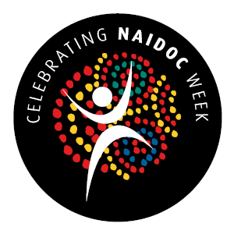
This Photo by Unknown Author is licensed under CC BY-NC-ND

