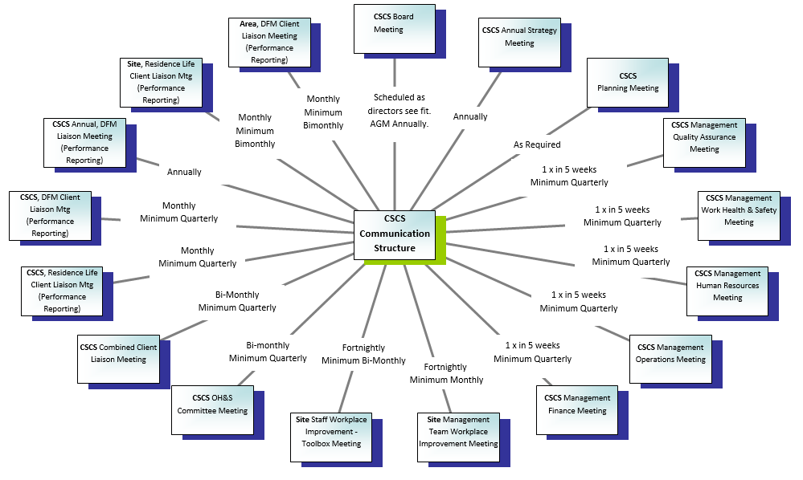

MEETING AGENDA & MINUTES DOCUMENT
MINUTE KEEPER PREPARES MINUTES AND DISTRIBUTES PRIOR TO MEETING
CHAIR CALLS EVERYONE IN AND GIVES A MEETING INTRODUCTION. (ATTENDEES RECORDED, APOLOGIES ACCEPTED, COMMENCEMENT TIME RECORDED, PREVIOUS MEETING MINUTES ACCEPTED)
A REVIEW OF PREVIOUS ACTIONS ITEMS OUTSTANDING AND COMPLETED IS CONDUCTED
A REVIEW OF ANY TABLED DISCUSSION ITEMS IS CONDUCTED
A REVIEW OF THE FOLLOWING DISCUSSION ITEMS WHERE RELEVANT IS CONDUCTED (THIS CAN BE DONE SITE BY SITE; DEPENDANT ON THE TYPE OF MEETING):
- Strategy Updates
- WORK HEALTH & SAFETY
- ENVIRONMENTAL SUSTAINABILITY
- FINANCE

- QUALITY ASSURANCE

MEETING CONCLUDED, TIME RECORDED, NEXT MEETING ORGANISED
- QUALITY ASSURANCE
- HUMAN RESOURCES/INDUSTRIAL RELATIONS
- CROSS CAMPUS TOPICS
- TRAINING
- ADMINISTRATION
- ACTION ITEMS
- OTHER

A REVIEW OF NEW ACTION ITEMS AND ITEMS TABLED FOR DISSEMINATION CONDUCTED

NAME OF MEETING:
DATE OF MEETING:
TIME OPEN: |  | TIME CLOSED:
ATTENDEES:
APOLOGIES:
CHAIR: | MINUTE KEEPER:
ACCEPTANCE OF PREVIOUS MINUTES OF THE SAME MEETING: YES/NO (DETAILS) :

ACTION TABLE FROM PREVIOUS MEETING

ACTION  ITEM | DESCRIPTION | ACTION REQUIRED |  | BY WHOM |  | BY WHEN |  | DATE CLOSED / COMMENTS

TABLED DISCUSSION ITEMS/NEW BUSINESS ARISING:

MINUTES:

ACTION TABLE THIS MEETING (INCLUDES ANY NON COMPLETED ACTIONS FROM PREVIOUS MINUTES)

ACTION  ITEM | DESCRIPTION | ACTION REQUIRED | BY WHOM | BY WHEN | DATE CLOSED

TABLED DISCUSSION ITEMS TO BE DISSEMINATED:

