- Click the link in the email notification.
- Wait for the incident to load.
- Review the incident details.
- Click on the investigation tab.
- Enter the date of investigation, by clicking on the calendar icon and selecting the correct date.
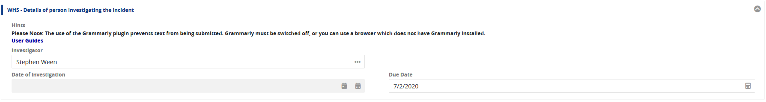
- Tick the Contributing Factors & Causes which led to the incident occurring.
- Type the details of the investigation findings into the Full Description of Events section textbox.
- If you have any evidence to include, such as emails, photos, videos or PDF documents, add them by drag and drop or clicking on the word “select”. If there is a risk assessment and Safe Work Procedure (SWP) related to the incident please attach these.
- If there are any actions required to prevent a similar incident occurring, in the Corrective Actions section select yes.
Click the Create New button.
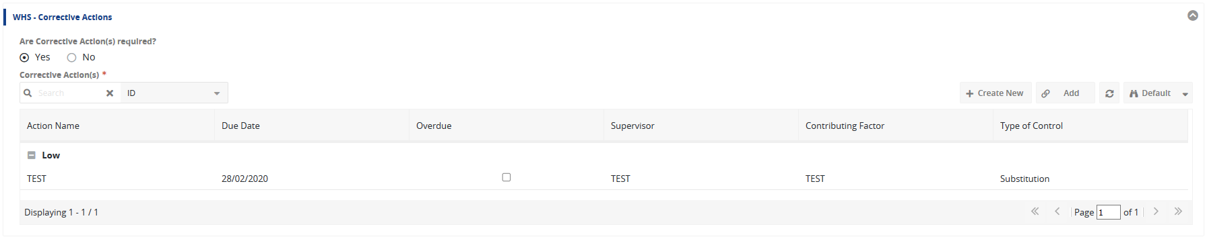

- Enter details into each field and make selections from the drop down menus.
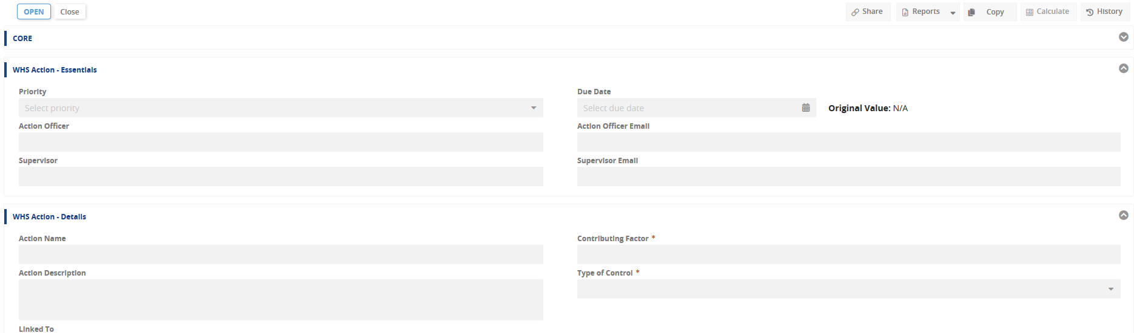
The contributing factor for each action should match one of the contributing factors identified in the investigation.
- If the corrective action is already completed go to step 18, otherwise click the Save and Close button.
- Repeat for as many actions as required.
- If all corrective actions are closed and the investigation completed, please go to step 26. Otherwise Click the Save and Close button and exit the window. Once you know that all corrective actions are completed, please start at step 14 below.
Closing corrective actions
- Click the link in the email notification.
- Wait for the incident to load.
- Click on the investigation tab.
- Double click the action in the table.
- At the top of the corrective actions window click the close button.
- Click the cancel button.
- Click the Save and Close button.
- If all corrective actions are closed and the investigation completed, please go to step 26.
Closing an investigation
- Click the link in the email notification.
- Wait for the incident to load.
- Click on the investigation tab.
- Check that all corrective actions are closed.
- At the top of the screen click the Review button. This submits the investigation to the WHS Unit for review.
- Click the Save and Close button.
- Exit the window.

