CAUTION RADIATION

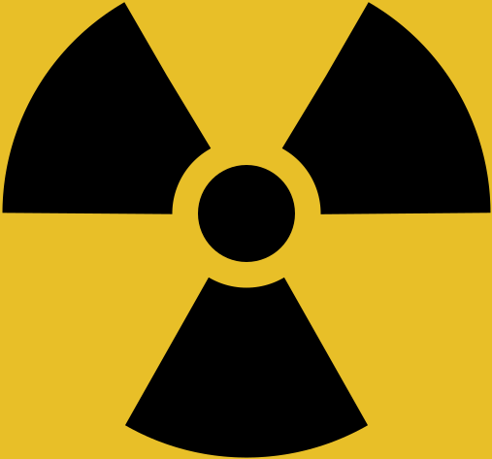

Unauthorised use is prohibited.

Hazardous radiation is emitted when the radioactive material is exposed from its shield.

Do not enter room without the correct protective equipment.

PLEASE TELL US IF YOU SUSPECT YOU MIGHT BE PREGNANT.

