Section Two
Get your hands dirty

Learning aims:
- This section is designed to focus on practical explorations of soil, both healthy and depleted, and how they function differently.
- Students will experience different soils and see the outcomes of ‘living soil’ for plants or fibres.

What is healthy soil?
Teacher notes: You may wish to talk about what soil is before discussing healthy soil. There is no agreed definition of soil itself. Here are two definitions used by the Australian government.
Soil is the loose surface material that covers most land. It consists of inorganic particles and organic matter. Soil provides the structural support for plants used in agriculture and is also their source of water and nutrients (https://agriculture.vic.gov.au/farm-management/soil/what-is-soil).
Soil is the thin layer of material covering the earth’s surface and is formed from the weathering of rocks. It is made up mainly of mineral particles, organic materials, air, water and living organisms—all of which interact slowly yet constantly (https://www.qld.gov.au/environment/land/management/soil/soil-explained/what-is-soil)

Class discussion: The teacher and class look at a range of resources (see below) and work together to define healthy soil.
Healthy soil is an ecosystem – it is full of life.
- Show the class the infographic (see below)
- Choose one or more options from the other resources in the table below (note some of these are also embedded in the slideshow – please edit the slideshow to select the resources you think are most useful and appropriate for our class).

You might like to consider the following questions in your discussion:
- From a human perspective, why are healthy soils important?
- What sorts of life forms exist in our soils?
- What are some of the key features of healthy soil (e.g., abundant micro-organisms and fungi, water holding capacity, organic matter and carbon, good texture)

Other potentially useful resources can be found in the table below
Other resourceshttps://soil.evs.buffalo.edu/index.php/Microarthropods
A Charles Sturt University website on the importance of healthy soil for human life | https://insight.study.csu.edu.au/healthy-soil/
Watch celebrity chef Matt Evans discuss the abundance of life in healthy soils, and how this contributes to plant growth | https://www.youtube.com/watch?v=Q-Vb7c5dj_g  from 0 up to about 6.00 minutes
This YouTube animation shows the symbiotic relationship between plants and the extensive networks of fungi in soil. | https://www.youtube.com/watch?v=v88gbtKBTv4
You might like to show the class some images of soil microarthropods to emphasise the idea of soil as a complex ecosystem full of life. | https://soil.evs.buffalo.edu/index.php/Microarthropods
This infographic was developed as a communications material as part of the Charles Sturt University/University of Tasmania project. There is not one consistent definition of healthy soil, but this infographic was put together with the help of soil scientists. At a minimum, healthy agricultural soils need to be productive – they need to be able to grow our food. The following suggested activities will help students gain hands-on experience and understanding of the difference between healthy/productive and depleted soils.
Option 1
Grow something in two types of soil: one dry and depleted, the other rich with organic material and microorganisms. Good options of things to grow include grass, cucumber or radish seeds, or seedlings of herbs or flowers.
Option 2
Soil your undies - https://cottoninfo.com.au/soilyourundies
This activity would require time in two lessons, several months apart. If there is not suitable space on the school grounds to bury undies, two large plastic tubs or planters could be set up in the classroom.
Both of these options could include the following classroom work:
- Set up parameters: Design the planting and burying with the class, and how it will be monitored. How often will indoor set-ups be watered? How much sun are they getting? Whether indoors or outdoors, will layers of leaves or other organic material be added at any point (when you initially plant/bury, or at a mid-way point)?
- Make predictions – ask students to record predictions about what will happen. For option 1, write down which plants will grow better, or how tall each set of plants will grow. For option 2, predict how much of the undies will be left by the time you plan to dig them up. Seal predictions in envelopes to open later.
- Keep track of growth of plants (option 1) or soil condition (option 2), making notes of changes in colour, texture etc.

Option 3
Water filtration experiment
Set up three containers of soil – one with grass or plants, one with mulch, and one with plain soil. Add water to them regularly over several weeks and look at the difference between the water that runs out of each container. The water run-off from the container with plants should have less sediment than that from the container with mulch, which should have less sediment than the container with no plant material. A number of examples of this experiment can be found online:
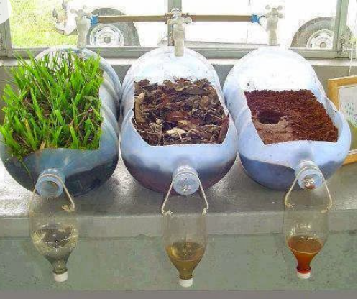
https://www.ealt.ca/kids-blog/water-filtration

Source: http://gardenreboot.blogspot.com/2013/10/plant-water-filteration-experiment.html

Techer note: In this package we use the terms soil health and healthy soil. While this term is commonly used, some soil scientists prefer other terms such as condition, function, capacity or quality. Many of these terms fit within the Soil Security Framework, as illustrated in the following infographic. The Soil Security Framework discusses soil across five domains: including Capability (what soil can do?, what it can be used for?); Condition (can the soil do this?, is it being improved or degraded?); Codification (what policies and regulations guide the use of soil); Capital (what economic and ecosystem benefits does soil provide; and Connectivity (how is soil understood and valued by all stakeholders, not just land users). The goal of Soil Security is to reward good soil management so that it facilitates profitable and productive agricultural systems and provides ecosystem services.
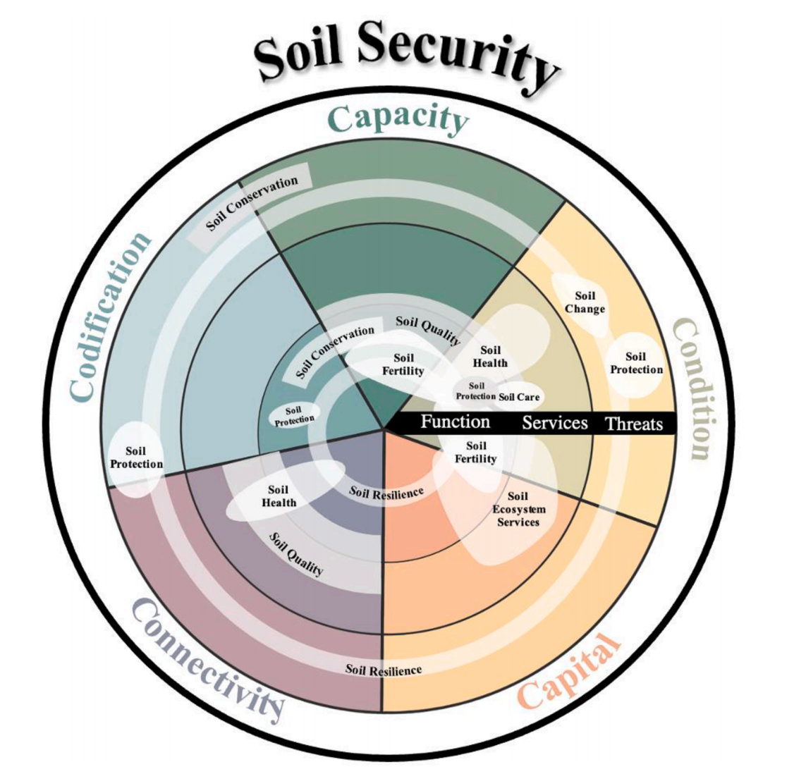
(Source: Evangalista et al 2023)
You may wish to include discussion of the Soil Security Framework. If so, the following article by Bennet et al. may be of use (https://doi.org/10.3390/su11123416).
Subsequent versions of this package may be updated to more fully incorporate the framework.

