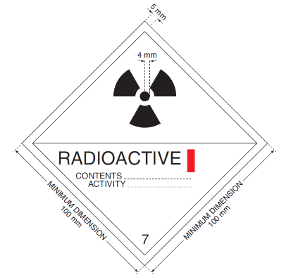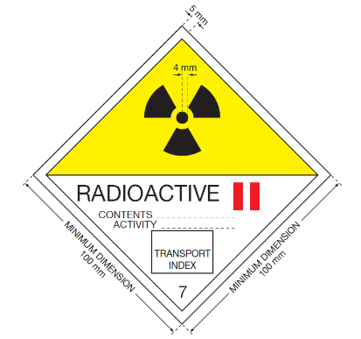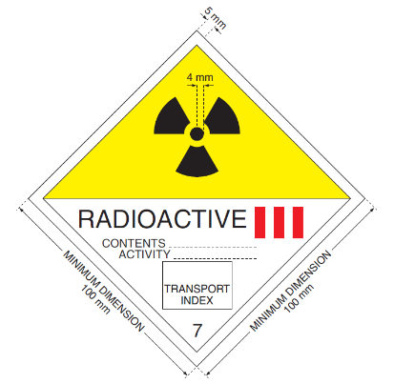

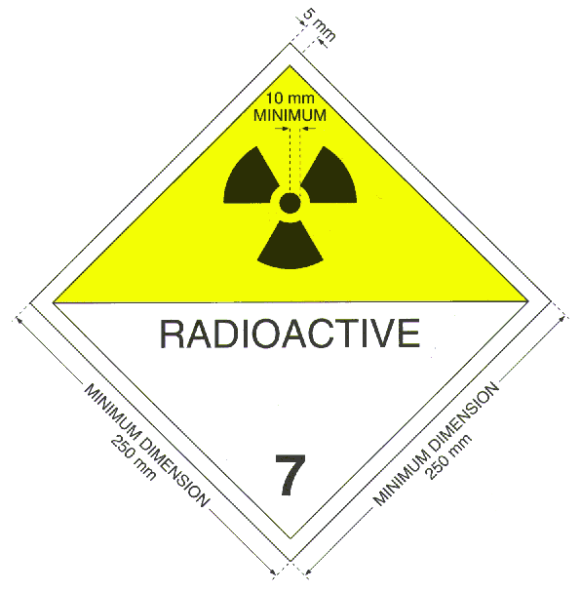

NSW H.U.R.S.O.G.
RADIOACTIVE MATERIAL TRANSPORT KIT AND
EMERGENCY PROCEDURES GUIDE

To be read and carried by all transporters of radioactive materials
(To be kept in the document holder in the driver’s door
or a conspicuous place in the driver’s compartment)

Transport of radioactive materials by public transport, taxis, or motorcycles is NOT PERMITTED

Carry packages securely:
- in boot of car, or
- away from driver in vans and station wagons, and
- segregated from non-compatible dangerous goods

Do not leave packages unsecured at ANY time.

For general radiation advice contact:
Radiation Control Section
Environment Protection Authority
Department of Environment and Conservation
Telephone: 02 9995 5959 (business hours).

In an Emergency, contact:
HAZMAT Team
Telephone: 000 (All hours)



