# Funding Toolkit: Example

## History and/or Background Information

There are no facilities in the South West Region which supports people experiencing homelessness. Other regions have established services with great success. This includes …

Despite large population in South West Region, nothing has been attempted so far. Barriers have been …

## Statistics

### Regional

* The rate of homelessness in South West Region is higher (29%) compared to other regions (ranging 5-15%)
* 6 out of 10 who experienced homelessness in South West Region were adults aged 55 or older

Ref: <https://www.facs.nsw.gov.au/District-Data-Profile.pdf>

### State-wide

* In the 2016 Census, approximately 37,000 people experienced homelessness in NSW.
* Rates of homelessness increased by 27% in 2016 (from 40 in 10,000 to 50 in 10,000)

Ref: <https://www.abs.gov.au/statistics/people/housing/census-population-and-housing-estimating-homelessness/latest-release#:~:text=In%202016%2C%20the%20rate%20of,per%2010%2C000%20persons%20in%202011>.

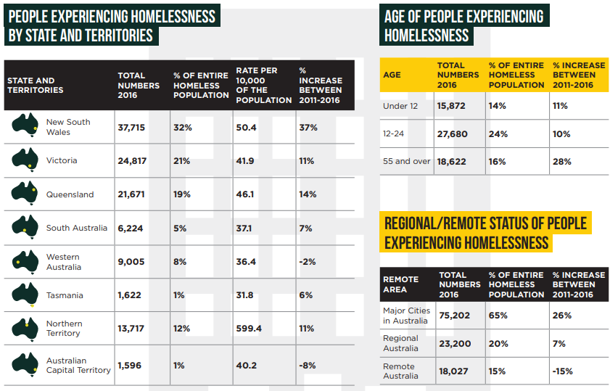

Ref: <https://homelessnessnsw.org.au/wp-content/uploads/2021/03/Homelessness-in-Australia-.pdf>

### Australia-wide

* 26% of people in Australia experiencing homelessness assess their health as fair/poor, compared to 14% in general population
* 13% (190,000) cited financial problems as a reason for homelessness
* Barriers to health care include referrals and follow up care

Ref: <https://www.aihw.gov.au/reports/australias-health/health-of-people-experiencing-homelessness>

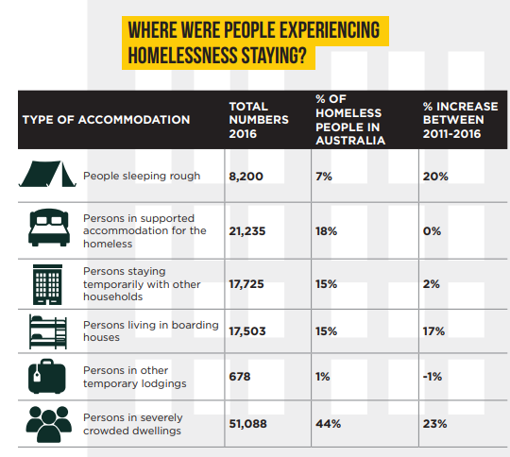

Ref: <https://homelessnessnsw.org.au/resource/nsw-census-data-and-hnsw-factsheets/>

## Local Case Studies

In the East Region, a health service was established for people experiencing homelessness, with health and employment services offered. Assisted 107 clients in past 12 months. Reported a 15% improvement in health outcomes and 11% improvement in employment outcomes. This is a model that could be replicated in the South West Region.

“Kristy (not her real name) was homeless for more than 10 years before she arrived at Common Ground. Previously socially excluded and extremely introverted, Kristy has started to recover her sense of self-worth. She has made friends with other residents and recently found the confidence to give a presentation to Mission Australia Housing staff about her battle with addiction. Raw and powerful, it was an invaluable insight into the challenges people like Kristy face.” (taken from Mission Australia website as an example, <https://www.missionaustralia.com.au/about-us/our-people/112-housing/225-case-studies>)

## Partner Information

|  |  |  |
| --- | --- | --- |
|  |  |  |
| Organisation: | Mission Australia | |
| Address: | Based in East Region | |
| Contact Name: | Joe Smith | |
| Phone: | 1234 5678 | |
| Email: | jsmith@missionaustralia.com.au | |
| Details relevant to project:   * In 2009, established 16 x 3 bedroom townhouses in East Region for people experiencing homelessness. Funded by X and Y organisations. * From 2009 to 2016, increased portfolio to more than 2,100 social and affordable properties across four States. * Looking to establish accommodation and services in South West Region. | | |

## Photos

Taken from Mission Australia website as an example (<https://www.missionaustralia.com.au/housing/who-we-are/stakeholders/what-we-do-sub>)

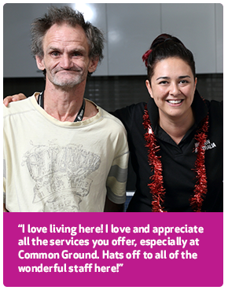

## Quotations

*“This project is vital in creating a program specifically for adults experiencing homelessness in the South West Region, and to provide services which are long overdue.”* South West Region Mayor, June 2022.

*“Adults experiencing homelessness who received these services in the South Region have had the opportunity to move forward with their lives and achieve their own goals which are otherwise obstructed by the barrier of homelessness.”* Partner Organisation, May 2022.

## Organisational Information

*For common CSU organisational information used in grant applications, see* [*Information for Grant Applicants*](https://research.csu.edu.au/funding-and-grants/find-a-funding-opportunity2)*.*

