CAUTION RADIATION

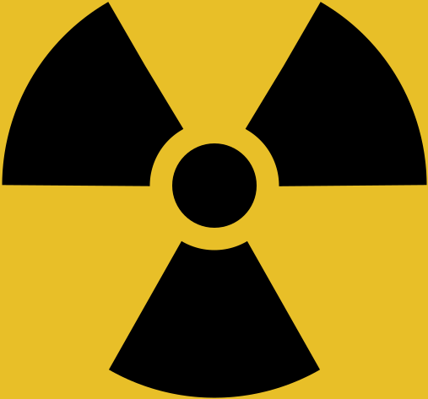

Unauthorised use is prohibited.

Hazardous radiation is emitted when the equipment is in operation.

Do not enter room when warning light is illuminated.

PLEASE TELL US IF YOU SUSPECT YOU MIGHT BE PREGNANT.

